Alejandra Celedon F.

Architectural Association

**Emilio Duhart Harosteguy (1917-2006)**

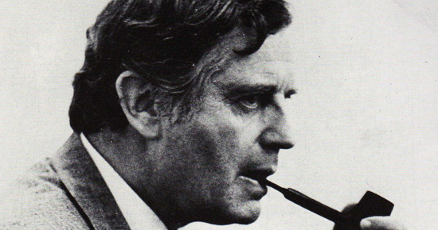

Figure 1: Emilio Duhart

In Montealegre, A. (1994) Emilio Duhart Arquitecto. Ediciones ARQ, Santiago.

The Chilean architect Emilio Duhart is one of the most recognised modern architects and urban planners in the country, especially because of the period he spent working as assistant for Walter Gropius and Konrad Waschmann in the States and for Le Corbusier in France, being involved in the planning of the city of Chandigarh in India. While he was born in Temuco, he spent his childhood, primary and secondary education, in France. He returned to Santiago and graduated as an architect from the School of Architecture at Catholic University in 1941, and continued his studies in Harvard University (Master in Architecture 1942) and the *Institutes the d’Urbanisme Sorbonne* (Master in Urban Planning 1952).

His first commissions were in relation the Chillan’s earthquake (1939) reconstruction working mainly in rural housing as part of the Help and Reconstruction Corporation initiatives (1941). He belongs to a group of architects that went abroad at the time and imported to Chile foreigner ideas and modes of architectural production. The other two main modes of dissemination were the architectural publications and external visitors to the country. He taught at Catholic University since 1951, becoming Director of the ‘Institute of Urbanism, Housing, and Planning’ at the same institution.

A prolific architect, his main work developed in the second half of the twentieth century, mainly devoted to educational buildings, private housing, and industrial plants. Highlights are the ‘Jardín del Este’ urbanization, and the ‘Carozzi’ industrial complex. His works include also large scales projects; such is the case of the urban zoning regulation plan in Concepción (1957-62), and the campus of the same city's university. He understood the urban project as a large-scale building, taking the human scale as the unit of territorial measure.[1]

The United Nations Building, which serves as headquarters to the Economic Commission for Latin America and the Caribbean (ECLAC), in Santiago, has been considered a landmark of modern architecture, and a referent of the movement in Chile and at the international level as well. Located in Vitacura, in the riverbed of Mapocho river, the building was inaugurated in 1966 and was designed in association with the architects Christian de Groote and Roberto Goycolea. Duhart asserted in his opening remarks for the competition entry that the complex ‘resembles both a house and a monument. This house of the nations represents a sharing with the community, while the monument is a visible expression of the nation’s social and spiritual aspirations.’[2] This government’s commission represents a general attitude of embracement of modern architecture as an efficient mode of promoting an image of a progressive nation. The investment in city planning and public buildings (schools, universities, hospitals, and social housing) was part of a strategy of diffusion of republican ideals, an image of moderness.

In 1961 Duhart establishes back in France where he dies 1988. From the distance he designed the ‘Comodoro Arturo Merino Benítez’ airport in Santiago (1992), receiving the Architectural National Award in 1977 for his trajectory.

**List of main works**

1941 Rosa Labbé de Mendez House

1945 Francisco Pinto Santa Cruz House

1948 Duhart House

1948 Mercedes Larraín Vial House

1950 Colegio del Verbo Divino

1953 Echeverría House in Zapallar

1955 Plaza de Armas Building

1957-62 Zoning Regulation Plan of Concepción and University Campus

Seminario Pontificio

Hostería Castro and Hostería Ancud

‘Jardín del Este’ urbanization

Capilla Colegio Verbo Divino

1961 Alliance Français high school

‘Carozzi’ industrial complex

1960-66 The United Nations Building

1971 Biblioteca Central Universidad de Concepcion

1992 Airport the International Commodore Merino Arthur Benitez

**References and further reading**

1. Eliash, H. (1989) Arquitectura y Modernidad en Chile / 1925-1965. Ediciones Pontificia Universidad Católica de Chile, Santiago.

2. Montealegre, A. (1994) Emil Duhart. Serie Monografías de Arquitectura Contemporánea, Ediciones ARQ, Santiago.

3. Montealegre, A. and Altikes P. (2011) Emilio Duhart Harosteguy. Procesos de cambio. AOA (17), p 24-41.

4. Pérez Oyarzun, F. and Pérez de Arce, R. and Torrent, H. (2010) Quantril, M (Ed) ‘Chilean Modern Architecture Since 1950,’ CASA, Chicago.

5. Archive: Fondo Documental Emilio Duhart, part of the Centre of Information and Documentation Sergio Larraín García-Moreno, Catholic University. Drawings and Images between 1945 – 1973.

**Visual Material**

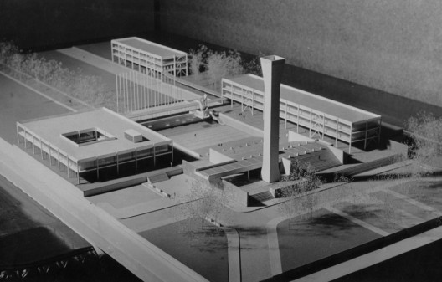

Figure : Zoning Regulation Plan in Concepción http://www.plataformaarquitectura.cl/2010/04/13/desenlace-del-instituto-de-quimica-de-emilio-duhart-en-concepcion/

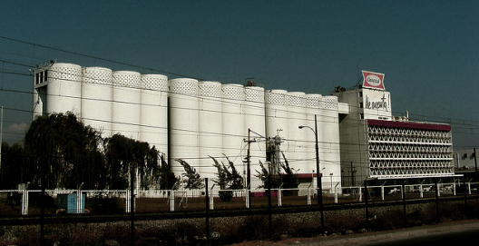

Figure : ‘Carozzi’ industrial complex’

http://www.plataformaarquitectura.cl/2010/08/03/se-incendia-fabrica-carozzi-de-emilio-duhart/

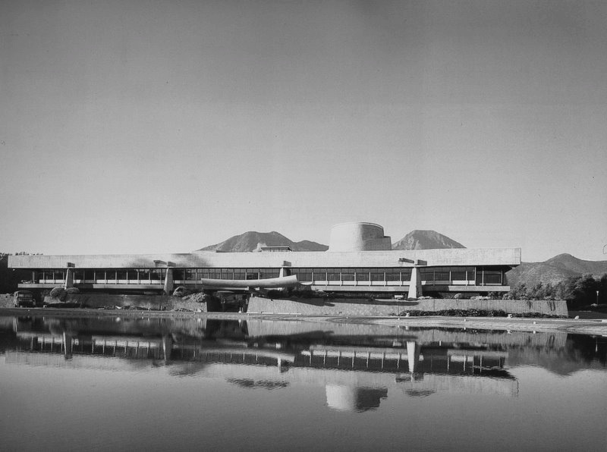

Figure : CEPAL building. Emilio Duhart Collection. Originals Archive, FADEU, Catholic University, Chile.

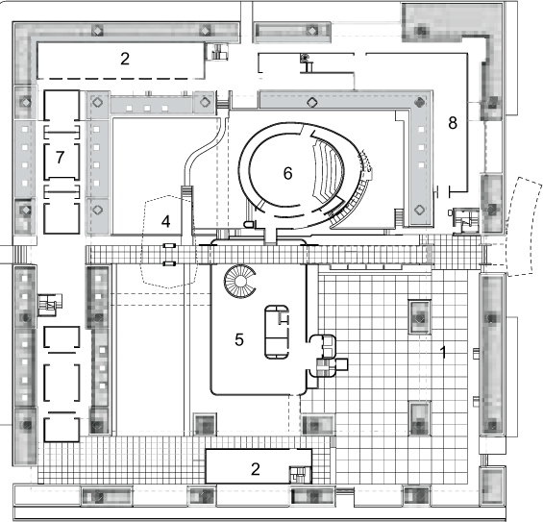 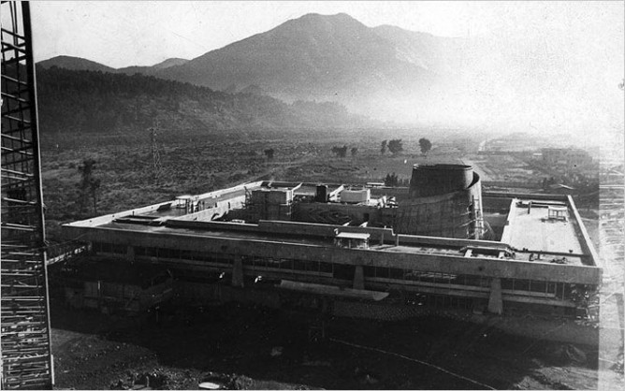

Figure : (left) Original Project of CEPAL by Emilio Duhart in 1960. Lower Ground Plan of Main Building. Guerra, J; Guevara, M; Morales, A. (2009) Rehabilitación en CEPAL. Vitacura, Santiago Arq, núm. 72, 2009, pp. 42-45, Pontificia Universidad Católica de Chile. (right) OBRA CEPAL · 1966 · Emilio Duhart. Source: Docomomo Chile

1. Berríos, C. (2007) Plan director de la Universidad de Concepción. Emilio Duhart 1957-62. Urbano, Vol 10, núm 16, November, pp 7-16. ISSN 0717-3997. Also in: REDALYC (Red de Revistas Científicas de América Latina, El Caribe, España y Portugal)
2. In Pérez Oyarzun, F. and Perez de Arce, R. and Torrent, H. (2010) Quantril, M (Ed) ‘Chilean Modern Architecture Since 1950,’ CASA, Chicago, p 62.